January monthly report
Sothearoth Heng
NCR ID: 803198
Under the supervision of
Dr. Pongkarn Chakthranont
Contract Number: NCR-NN-2023-20170-EN
January 2024
Project Title:
Development of Cu-based catalyst for electrochemical CO₂ reduction to C₂ products: combined computational chemistry and electrochemical engineering approach
Checked by:
...........................................................
Dr. Pongkarn Chakthranont

- Tasks list for January
- Synthesis of Ag NPs and NH₂-Ag with modified methods.
- Spray coating as-prepared Ag samples to be used as cathode electrodes.
- eCO2RR performance test of spray-coated cathodes.
- Comparison of eCO2RR performance of different sputtered Ag cathode thickness (450nm and 100nm).
- Investigation of CO2RR performance under different anodic systems in MEA.

- Experimental Procedure
Synthesis of Ag NPs
Briefly, 1.91 g of AgNO₃ precursor was thoroughly dissolved in 150 ml of DI water to make 75mM AgNO₃ solution. NaBH₄ was used as a reducing agent. 0.47 g of NaBH₄ was carefully dissolved in 150 ml of cold DI water under 0°C ice bath and stirring rate of 500 rpm. Afterwards, the AgNO₃ solution was slowly dropped into NaBH₄ with a flow rate of 1 ml/min, and then a transparent solution turned into black color, indicating the formation of Ag NPs. After completely adding AgNO₃ solution, the mixture solution was further stirred at 500rpm for another hour to complete the reaction. The precipitated Ag product was filtrated and washed by DI and EtOH for several time and followed by drying under 60°C for 6h. The obtained Ag NPs was further characterized.

Synthesis of NH₂-Ag NPs
Initially, 16.4 mg of NaCl and 1.34 PVP (MW = 55000) were dissolved and vigorously stirred in 20 ml of ethylene glycol (EG) to make a transparent solution (denoted as solution A). 0.69 g of AgNO₃ was dissolved in 10 ml of EG to make a silver solution, (denoted as solution B). 31.1 mg of butylamine (BNH₂) was also dissolved in 10ml of EG to obtain a functionalized-ligand solution (denoted as solution C). Each solution was stirred for 30min to completely dissolve the precursors. Afterwards, the solution B was slowly dropped to solution A under stirring for 30min, and followed by solution C for another 30min under the same stirring rate. 8 ml of glycerol was then added into the above mixture solution for 30min to form a colloidal dark brown solution. Next, the colloidal solution was transferred to a 100 ml Teflon-lined stainless autoclave and placed in an oven at 160°C for 2h. Finally, the precipitated NH₂-Ag NPs product was centrifuged, washed with EtOH for several time, and overnight dried under 40°C in vacuum oven. The obtained NH₂-Ag NPs was further characterized.

Preparation of Ag cathode electrode
The as-prepared Ag NPs and NH₂-Ag catalyst was spray-coated onto Sigracet 36BB carbon paper. As-prepared Ag and 5 wt% of Nafion were sonically mixed with EtOH for 30 min to form a homogeneous solution which then was sprayed onto carbon paper with 0.5 ml/min at 90 °C to obtain ~0.65 mg/cm².

Electrochemical CO2RR measurements
A 5 cm² MEA electrolyzer was used to evaluate the CO2RR performance of different cathodes. The NiFe foam and AEM (X37-50 Grade RT, Dioxide Materials) were employed as the anode and membrane, while different Ag cathodes were also used. 50 ml of 0.5 M KOH was recirculated and used throughout the experiment as the anolyte with 10 ml/min (unless specific anode catalyst and anolyte are mentioned). 30 ml/min of humidified CO₂ at 30 °C was fed at the cathodic inlet stream. The cathodic outlet was directly injected into an online gas chromatography for further gas products analysis.

- Result
eCO2RR performance of Ag NPs and NH₂-Ag cathodes
To investigate the catalytic activity and electrochemical CO₂ performance of the as-prepared Ag NPs and NH₂-Ag, these samples were spray-coated on carbon paper and employed as cathode electrodes in MEA electrolyzer under operating applied j. The Ag NPs cathode with a mass loading of approx. 0.65 mg/cm² (Ag particle size of 100nm, according to SEM) showed similar performance in terms of %FE (CO) to NH₂-Ag at 100 mA/cm². Upon raising j to 200 mA/cm², %FE(H₂) of both Ag NPs and NH₂-Ag was substantially increased, especially the Ag NPs with a %FE(H₂) of approx. 85%. Further increasing j to 250 mA/cm², %FE(H₂) of the NH₂-Ag cathode abruptly increased to approx. 82%. This phenomenon is a common issue in a zero-gap MEA electrolysis cell once operating at high current density due to the formation of K₂CO₃ salt and flooding at the cathode side that could facilitate the hydrogen evolution reaction (HER). On the other hand, these results indicated the applicability of the as-prepared Ag samples towards CO2RR in the MEA cell. Therefore, further optimizations on MEA system and Ag cathode electrode should be conducted to maximize eCO2RR performance of the overall MEA electrolyzer.

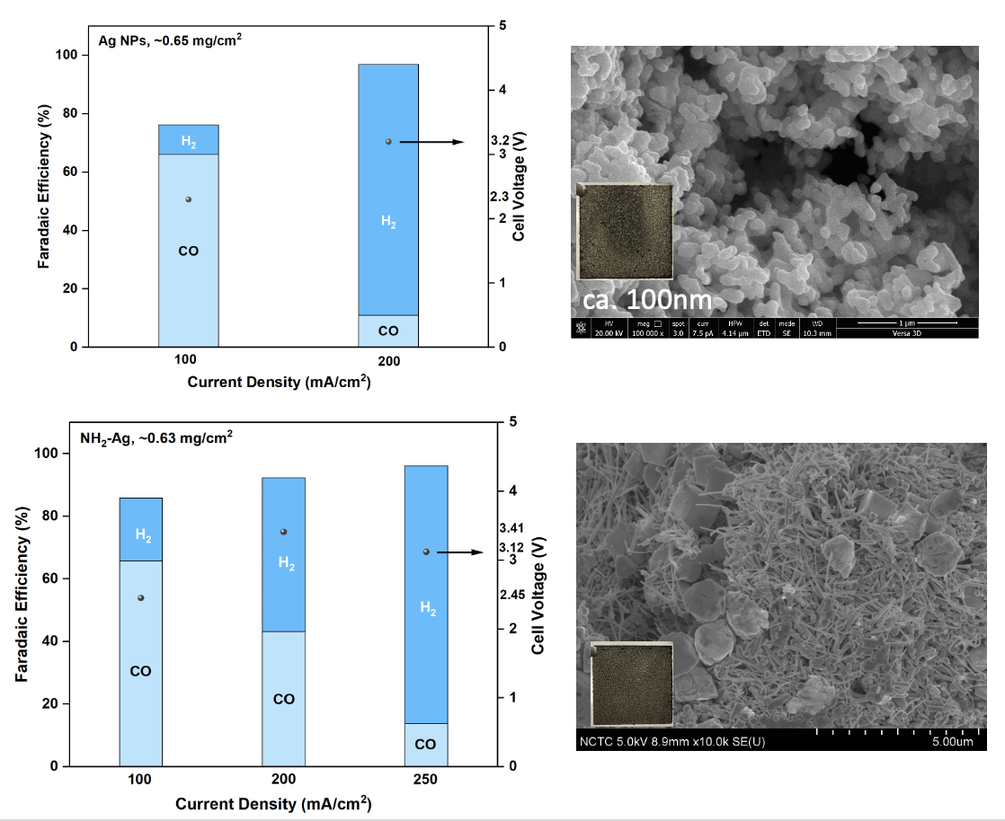
Figure 1. Faradaic efficiency results under different j and FE-SEM images of Ag NPs and NH₂-Ag samples.

eCO2RR performance of sputtered Ag_{450nm} and Ag_{100nm} cathodes
The catalyst thickness strongly impacts the catalytic performance, selectivity, and mass transfer of CO₂ to the active surface. Fig. 2 exhibited comparable electrochemical performance of sputtered Ag_{450nm} and Ag_{100nm} cathodes under applied j of 200 mA/cm² with similar %FE and cell voltage. Therefore, a sputtered Ag_{100nm} cathode will be selected for further studies on MEA optimization.

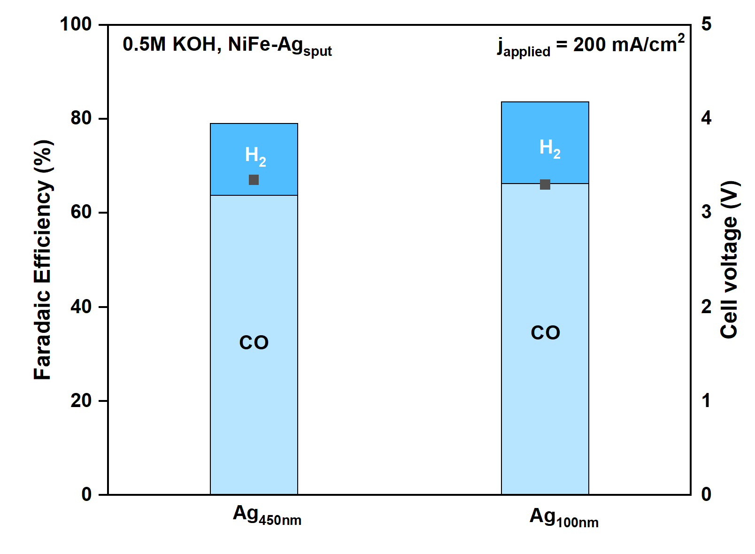
Figure 2. Faradaic efficiency of 450nm and 100nm sputtered Ag at 200 mA/cm².

eCO2RR performance of different anodic systems
The benchmark IrO₂ is exclusively used as the anode catalyst due to its compatibility, high stability, and OER activity. On the other hand, Ni catalyst is an alternative anode material due to its low cost and great OER catalytic activity, yet poor stability. In a zero-gap MEA electrolyzer, the anodic system strongly influences the overall electrolyzer performance. Thus, carefully and logically choosing a suitable anode catalyst is required. In Fig. 3, we investigated the impact of anodic systems toward CO2RR performance under applied j range of 100-300 mA/cm². As can be seen, despite a slightly high FE(H₂) of NiFe anodic system at higher j, two different anodic systems (NiFe foam with 0.5M KOH and IrO₂ with 0.1M KHCO₃ anolyte) exhibited similar outcomes in terms of FE(CO) and cell voltage. However, after a prolonged operation of CO₂ electrolysis at a high j, the carbonate/bicarbonate ions were inevitably migrated to the anode side, causing an anolyte becomes more acidic (low pH). In the NiFe foam with 0.5M KOH anodic system, we observed the degradation of Ni and formation of NiCO₃ due to a pH decrease in the anolyte and local chemical environment change. Furthermore, a fraction of dissolved Ni ions could also diffuse to the silver catalyst, thereby poisoning the cathode catalyst surface. Conversely, the IrO₂ with 0.1M KHCO₃ anodic system was stably operated even at a high j and long period of CO₂ electrolysis. Despite all of that, the overall performance of both MEA systems was almost identical. Additionally, if we carefully optimize the anolyte concentration (Despite the consequence of substantial salt build-up) and shorten the CO₂ electrolysis period (Using microGC), these could make Ni a viable anode catalyst in a zero-gap MEA cell.

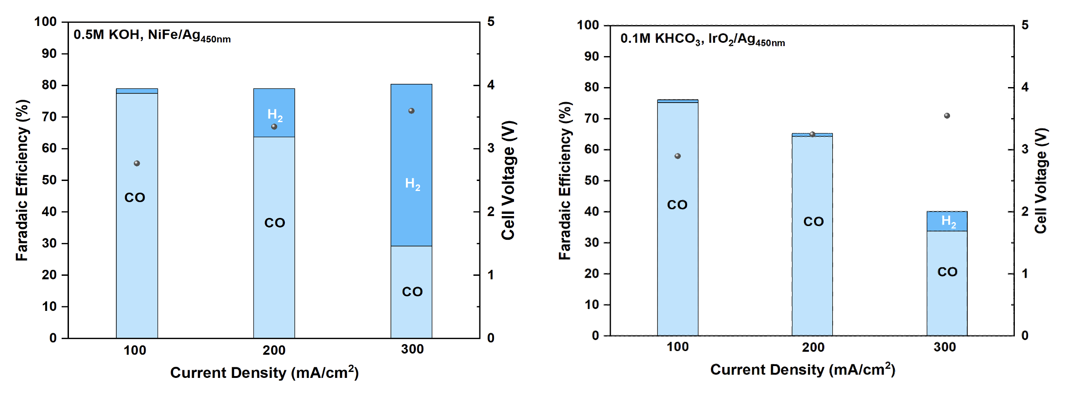
Figure 3. Faradaic efficiency of MEA electrolyzer under different anodic systems and j of 100-300 mA/cm².

eCO2RR performance of prolonged CO2RR and fresh cells
Fig. 4 illustrates the effect of prolonged CO2RR operation on cathode performance and selectivity. When comparing used and fresh cells, both cells achieved similar FE(CO), but a slightly higher FE(H₂) was observed for the used cell. This could be attributed to water crossover and accumulation on the GDL inducing a high hydrophilicity of the cathode, thus facilitating HER. In order to minimize a competing HER and other factors, a fresh cell should be operated.
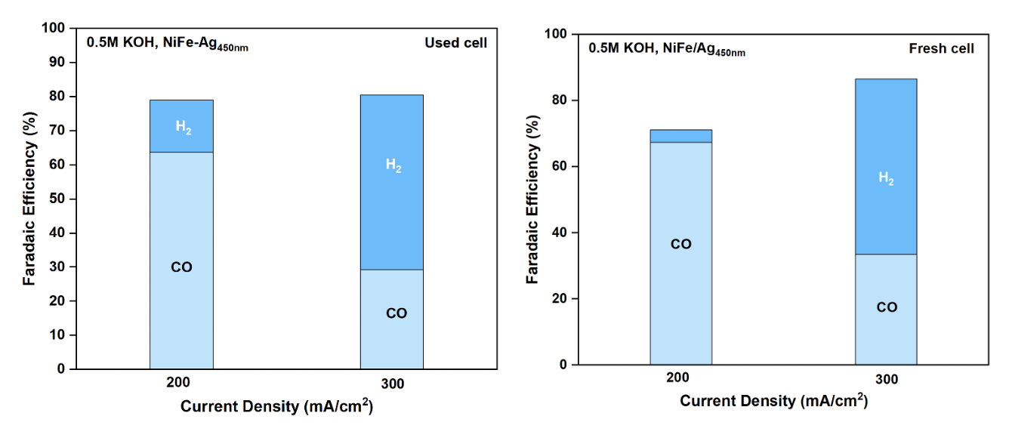
Figure 4. Faradaic efficiency of prolonged CO₂ electrolysis and fresh cells under 200-300 mA/cm² with a cell configuration of NiFe/AEM/Ag_{450nm}.

- Summary
The as-prepared Ag NPs and NH₂-Ag were spray-coated onto Sigracet 36BB carbon paper and employed as cathodes in CO2RR performance test. Both cathodes showed the applicability in CO2RR with %FE(CO) of approx. 63% at 100mA/cm², but experienced flooding at higher j of 200 and 250mA/cm². A sputtered Ag cathode with thicknesses of 100 and 450 nm demonstrated comparable performance under 200 mA/cm². Furthermore, despite a poor stability of Ni at higher j, the CO2RR of both anodic systems (IrO₂ and NiFe foam) showed comparable overall performance under j of 100-300mA/cm². Additionally, results from the comparison of used and fresh cell revealed water crossover and accumulation on the GDL over time, leading a slightly increase in FE(H₂) in the prolonged CO2RR cell. These results imply that further MEA cell optimization is needed.
- Upcoming tasks
- Optimization of a MEA system with a cell configuration of NiFe/AEM/Ag_{100nm} at 200mA/cm²:
  - [KOH]: 0.5-1.5 M
  - Anolyte flow rate: 1-20 ml/min
  - Cathodic humidity: 30-70 C
  - CO₂ flow rate: 20-40 ml/min
- Optimization of Ag ink with varied Nafion quantity, mass loading, and type of solvent.

